Project 2

James S. Cole

Student, SNHU

CS-255-12571-M01

Denise Washington

10/18/2026

CS 255 System Design Document Template

UML Diagrams

UML Use Case Diagram

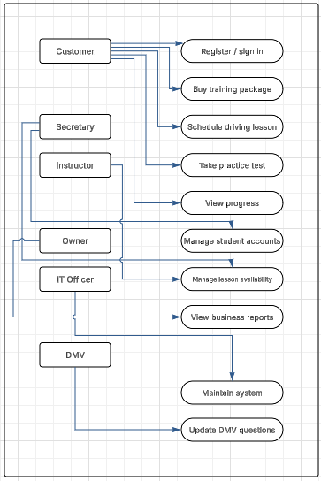

UML Activity Diagrams

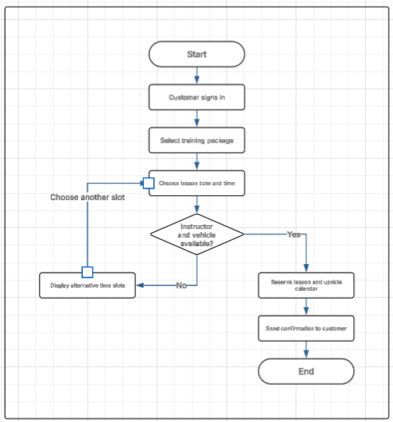

UML Sequence Diagram

Scheduling a driving lesson: messages travel between the customer, website, booking service, database, and notification service. The database must prevent duplicate reservations.
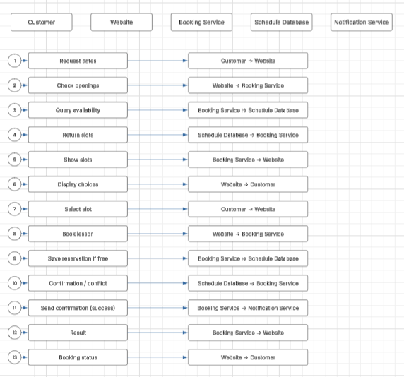

UML Class Diagram
The data design stores people, packages, bookings, vehicles, practice tests, attempts, and DMV updates. Relationships show how records are connected.

UML Class Diagram

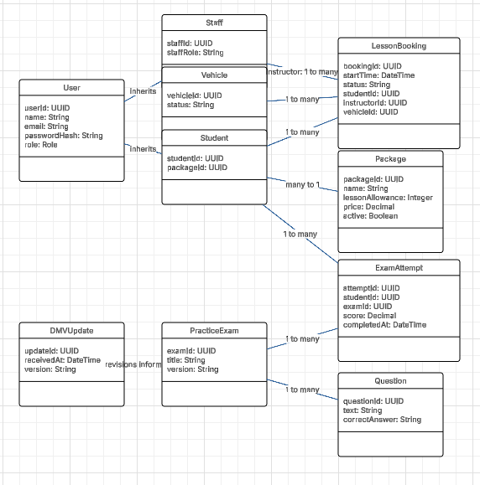

Technical Requirements

Hardware

Students need an internet-capable phone, tablet, or computer. Staff need standard office computers; instructors may use mobile devices. Hosting requires virtual application and database servers, redundant storage, and routine backups.

Software
A responsive browser-based application, a server-side application/API, and a relational database such as PostgreSQL. Use supported operating systems, modern browsers, email notification service, and a protected administration interface.

Tools
Lucidchart for UML modeling; source control such as Git; an IDE; automated testing, issue tracking, logging, and monitoring tools. Use separate development, testing, and production environments.

Infrastructure
Secure cloud hosting, HTTPS/TLS, firewalls, identity and role-based permissions, encrypted data storage, managed database backups, recovery testing, and scalable application capacity. Reliable internet access is needed for online features.

Functional support
Customer registration and authentication; practice tests and progress reports; package management; lesson booking, changes and cancellations; instructor/vehicle availability; management reports; and controlled DMV content updates.

Quality and security
Design for usable mobile/desktop screens, accessibility, responsive performance, availability monitoring, input validation, password hashing, audit logging, session expiration, and least-privilege staff access. Payment processing, if implemented, should use a trusted processor rather than storing card numbers.

Constraints and assumptions
Real-time booking requires internet access and accurate staff/vehicle schedules. DMV content updates depend on receiving verified information. Offline testing, automatic DMV integration, and specific uptime targets are not assumed without client approval.

